Find all info abouct each product

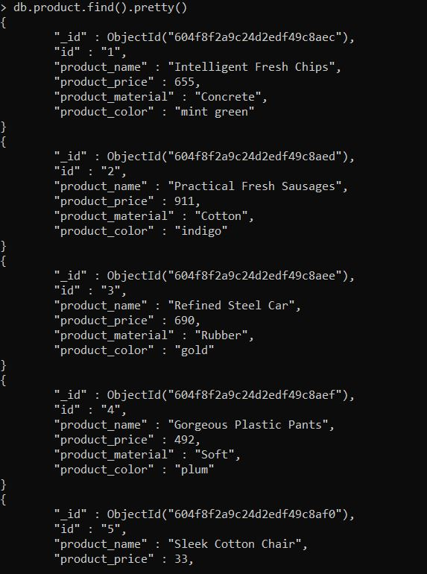

Find product price between 400 to 800;

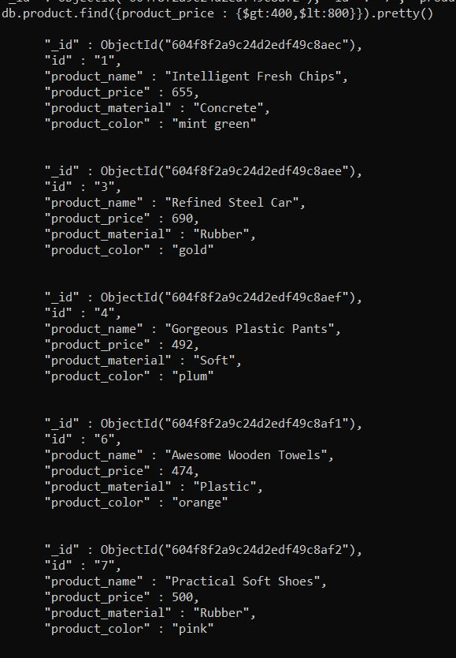

Find product price between 400 to 800;

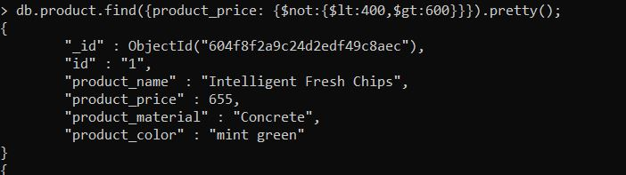

Product price greater than 500

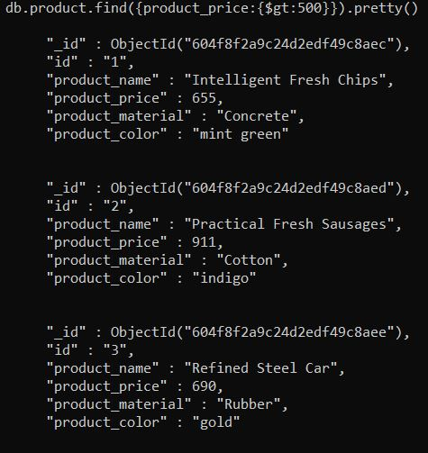

Product_name and material of each

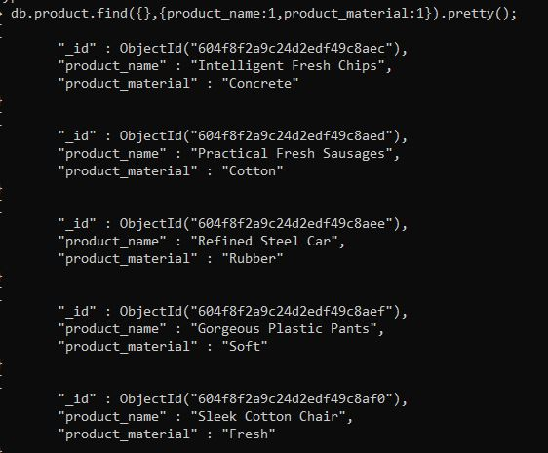

Find all contain soft

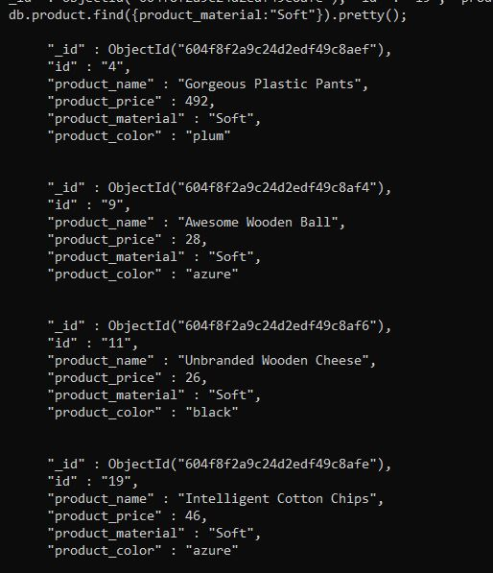

Find only product name and material



Find product colour indigo and price 492

